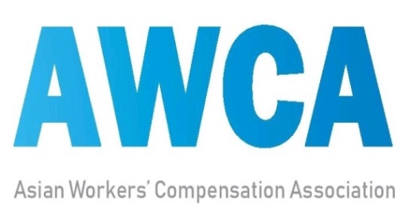 | MEMBERSHIP APPLICATION

◈ Organization Data
Country
Name of Organization
Address of HQs.
Internet website
Name of Head
※ Please share with AWCA Secretariat more detailed English information of the applicant organization.

◈ Membership Type(a check mark (√) in one box)
- Regular member □ Associate member
※ For more information of the membership type, please see the reverse page.
◈ Contact Point
Name
Position
E-mail
Tel.
Date: ____________________ Signature:_____________________________

K-COMWEL(Korea Workers’Compensation & Welfare Service)
Address : 340, Jongga-ro, Jung-gu, Ulsan, Korea
International Relations & Research Team, Labor Welfare Research Institute
Address : 8, Beodeunaru-ro 2-gil, Yeongdeungpo-gu, Seoul, Korea
E-mail : international@comwel.or.kr
Internet website : www.comwel.or.kr / www.asianwca.org
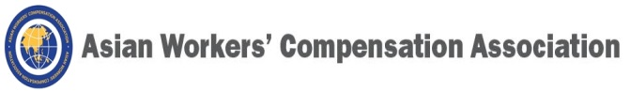
◈ Membership Type
- Regular member | Government organizations or other public or non-profit entities having engaged in or been involved with the operation of a workers’ compensation or employment injury insurance scheme in Asia
- Associate member | International or government organizations, or other public or non-profit entities having engaged in or been involved with supports for the operation of a workers’ compensation or employment injury insurance scheme or other relevant activities

◈ Member Organizations(as of 30 June 2019)
Cambodia | NSSF: National Social Security Fund
Indonesia | BPJS Ketenagakerjaan
Korea | K-COMWEL: Korea Workers’ Compensation & Welfare Service
Lao PDR | MOLSW: Ministry of Labor and Social Welfare
 | NSSF: National Social Security Fund
Malaysia | SOCSO: Social Security Organization
Mongolia | GASI: General Authority for Social Insurance
Philippines | ECC: Employees’ Compensation Commission
 | SSS: Social Security System
Sri Lanka | DOL: Department of Labour
 | OCWC: Office of the Commissioner for Workmens’ Compensation
Thailand | SSO: Social Security Organization
Vietnam | VSS: Vietnam Social Security

